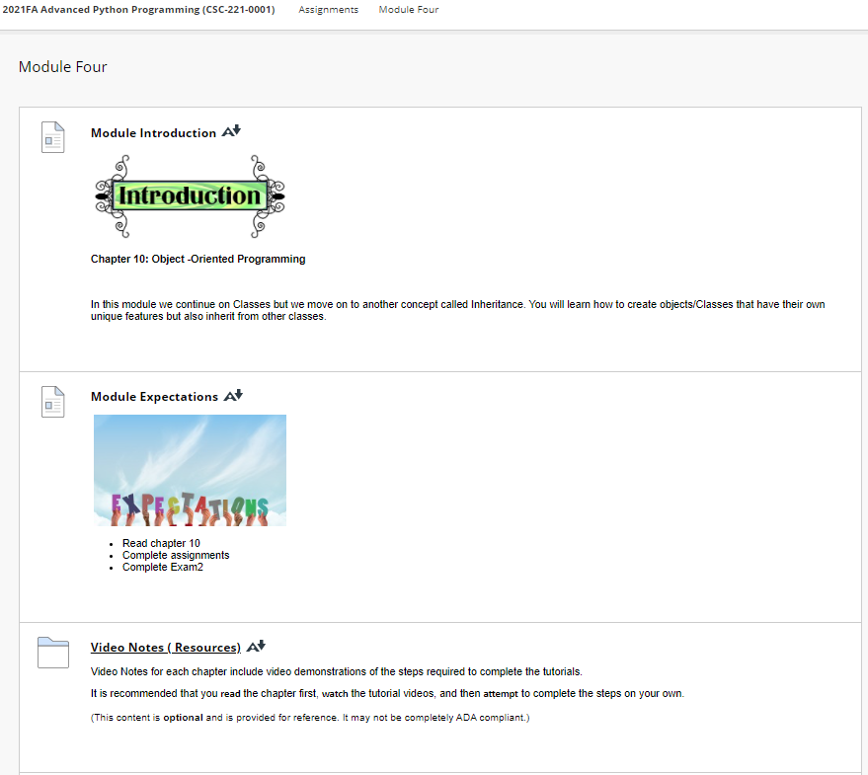

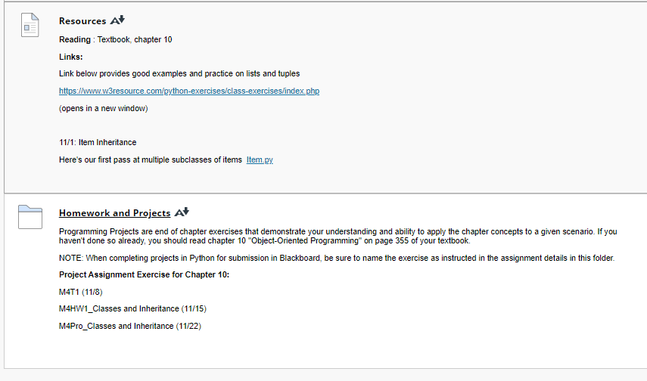

[**Video Notes ( Resources)**](https://faytechcc.blackboard.com/webapps/blackboard/content/listContent.jsp?course_id=_35059_1&content_id=_5950120_1)

[Video Notes ( Resources)](https://faytechcc.blackboard.com/webapps/blackboard/content/listContent.jsp?course_id=_35059_1&content_id=_5950117_1)

Video Notes for each chapter include video demonstrations of the steps required to complete the tutorials.

It is recommended that you **read** the chapter first, **watch** the tutorial videos, and then **attempt** to complete the steps on your own.

(This content is **optional** and is provided for reference. It may not be completely ADA compliant.)

same as mod 3

**Resources**

[Resources](https://faytechcc.blackboard.com/webapps/blackboard/content/listContent.jsp?course_id=_35059_1&content_id=_5950117_1)

**Reading** : Textbook, chapter 10

**Links:**

Link below provides good examples and practice on lists and tuples

<https://www.w3resource.com/python-exercises/class-exercises/index.php>

(opens in a new window)

11/1: Item Inheritance

Here's our first pass at multiple subclasses of items  [Item.py](https://faytechcc.blackboard.com/bbcswebdav/pid-5950121-dt-content-rid-55979212_1/xid-55979212_1)